Context
For stage testing, the stage must always be fixed to the ground. To achieve this, 4 hydraulic actuators are mounted to the ground with a rope connecting it to the top of the stage. A force sensor is inline with the rope and actuator.
The actuators need to hold the stage onto the ground while not overloading the stage and buckling it. The mounting points at the top of the stage are only rated to hold the stage down when the stage is at max weight. As the weight of the stage decreases due to propellant flow, the total force of the actuators must increase to account for the decrease in weight.
The RMC200 controller will be used to control the 4 actuators such that the force of the actuators keeps the stage firmly to the ground without overloading the stage. It will also need to manage the force of the actuators such that the stage does not bend and remains upright.
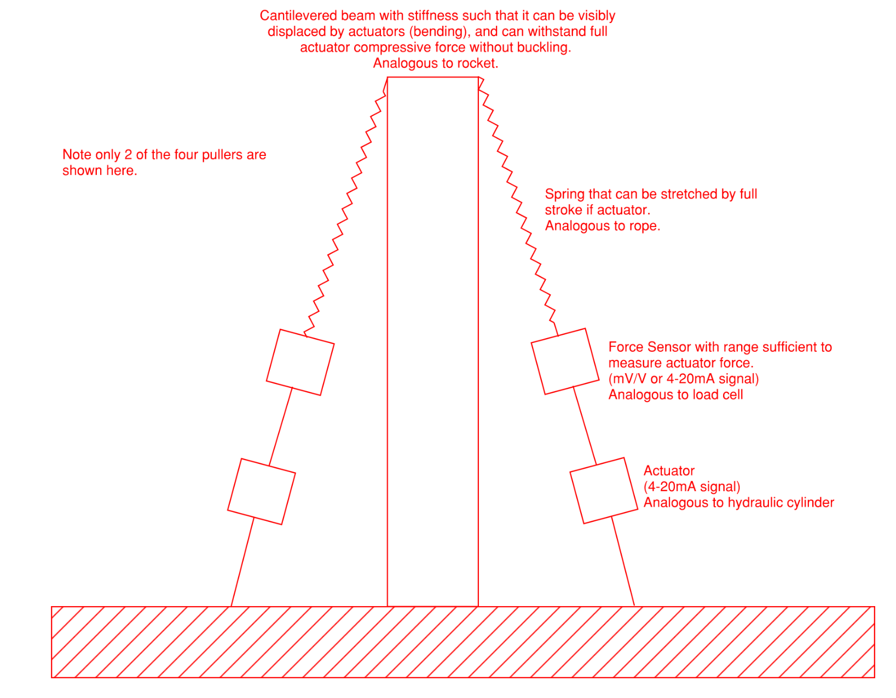

Purpose
The purpose of the RMC HITL project is to create a HITL environment to test the operation of the RMC200 controller. It will allow an operator to run a program on the RMC and visualize the operation of the controller.
The HITL environment must simulate the output of the force sensors inline with the actuator and rope as well as position feedback from the actuators. The environment will take in the commanded position for each actuator and iterate the simulation.
The HITL environment should model the statics of the actuator, ropes (modeled as springs), and stage. It should also dynamically model the stage as varying forces are applied to it.

HITL Environment Requirements

Modularization
Each “device” should be setup as a class with easily definable attributes.

Instrumentation
- Provides either a mV/V or 4-20mA output for each load cell force.
- Provides a 4-20mA output for each actuator position.

Control Inputs
- Takes in a 4-20mA input for actuator position.

Simulation Visualization
- Plots
  - Commanded actuator position
  - Rope force
  - Total applied force to stage
  - Ground force (Applied + Weight – Thrust)
  - Displacement of top of stage (x and y)

RMC200 Notes

